**12 c New Features**

1. **Truncate table with cascase option**

Creating tables for Demo.

create table **my_Category**(category_id number,category_name varchar2(50), constraint product_id_pk PRIMARY KEY(category_id));

create table **my_product**(product_id number, product_name varchar2(50), category_id number,constraint product_pk PRIMARY KEY(product_id),constraint product_Category_fk foreign key(category_id) references my_Category(category_id) on delete cascade);

insert into my_Category values(1,'LED TV');

insert into my_Category values(2,'LCD TV');

insert into my_Category values(3,'SMART TV');

insert into my_Category values(4,'3D SMART TV');

insert into my_product values(1,'32 Inches TV',1);

insert into my_product values(2,'40 Inches TV',2);

insert into my_product values(3,'50 Inches TV',3);

insert into my_product values(4,'45 Inches TV',4);

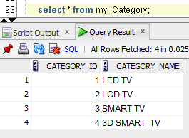

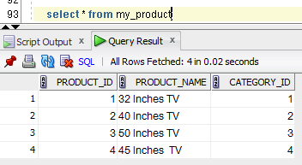

Now deleting from parent table

delete from my_Category;

since table is created with on delete cascade data is deleted from child table as well.

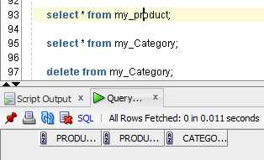

Now trying to truncate child table

Getting error as parent data is referred in child table.

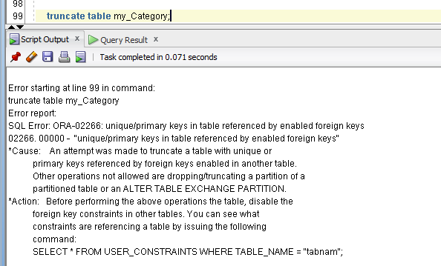

Now trying to truncate with cascade.

truncate table my_Category cascade;

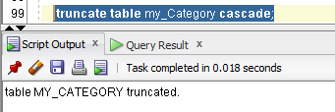

It worked same as delete with cascade.

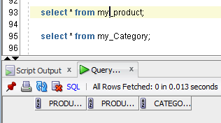

Same command in oracle 11g throws errors

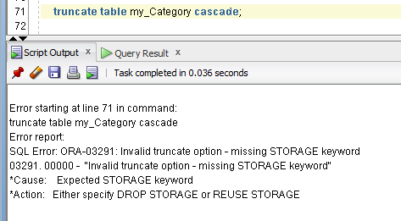

1. **Multiple indexes on same column**

Creating table for demo

create table my_Category(category_id number,category_name varchar2(50));

insert into my_Category values(1,'LED TV');

insert into my_Category values(2,'LCD TV');

insert into my_Category values(3,'SMART TV');

insert into my_Category values(4,'3D SMART TV');

created normal index

create index indx_1 on my_Category(category_id);

When we try to create another index on same column it throws error.

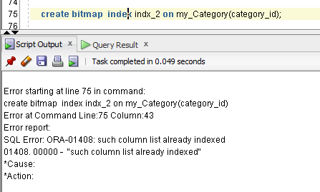

Samething we can do with invisible option

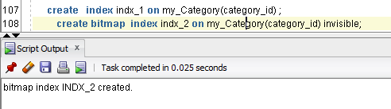

We can see from user_indexes table same column has two indexes.

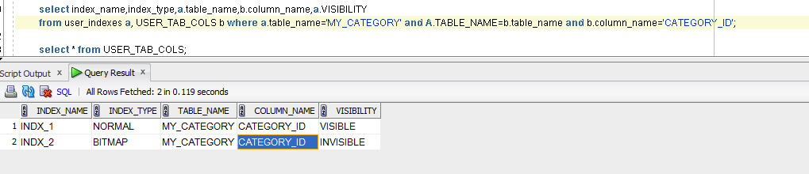

We can alter index to make it visible/invisible

alter index INDX_1 invisible;

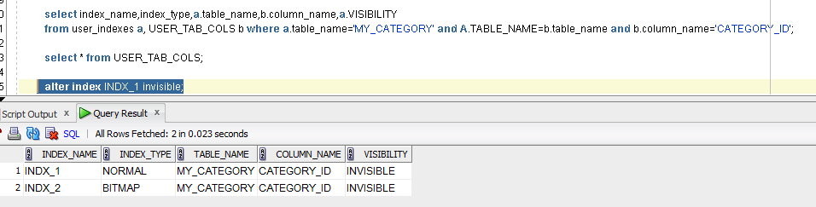

There can have only one visible index on column

If we try to make both visible will get below error

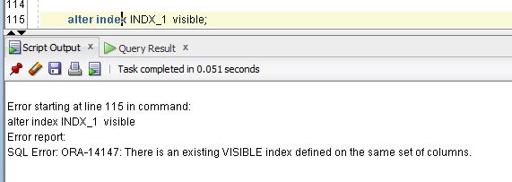

Now bitmap index is visible so optimizer s taking that index.

select * from my_Category where CATEGORY_Id=4 ;

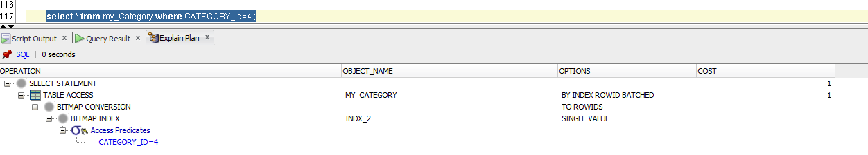

Now making normal index as visible , it is taking normal index

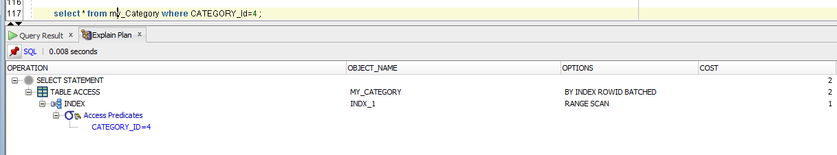

Samething if we try in 11g it throws error.

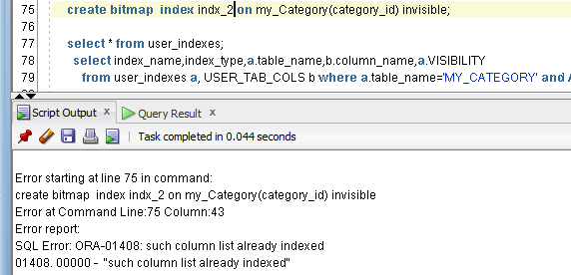

1. **APPROX_COUNT_DISTINCT**

This function will return approximate distinct number of rows.

Here we can see records in table.

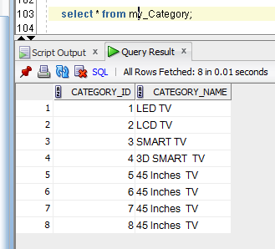

Now running below query to find the count of distinct record.

select count(distinct category_name) from my_Category;

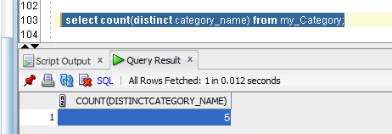

Now replacing it with new command approx_count_distinct

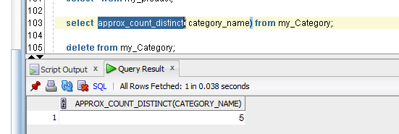

**Same in 11g throws error**

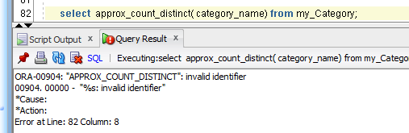

1. **IDENTITY column for generating sequence value**

Normally we use sequence for generating unique values.

1n 12c we use identity column to generate new sequence values.

Below are options

1. Generated always as identity – used to generate unique values always.
2. Generated by default as identity
3. Generated by default on null as identity

Creating table for demo

create table my_identity(id number generated always as identity,name varchar2(30));

insert into my_identity(name) values ('AAA');

insert into my_identity(name) values ('BBB');

insert into my_identity(name) values ('CCC');

insert into my_identity(name) values ('DDD');

insert into my_identity(name) values ('EEE');

now we will see data in table, unique values for id column will be generated.

select * from my_identity;

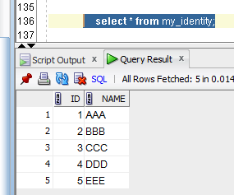

It wont allow to insert null or default values with generated always as null

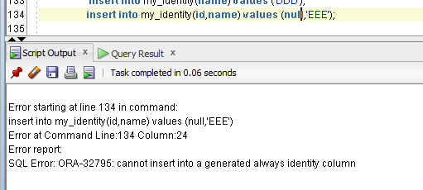

Trying with default values

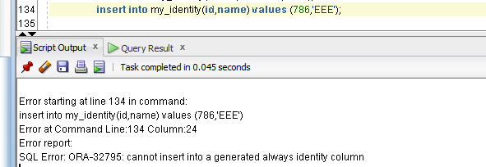

**Now we can achieve inserting default value by generated by default as identity**

create table my_identity(id number **generated by default as identity**,name varchar2(30));

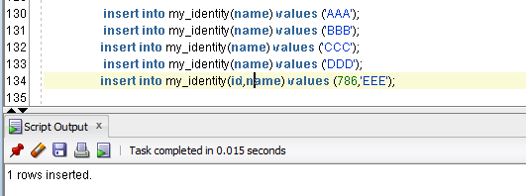

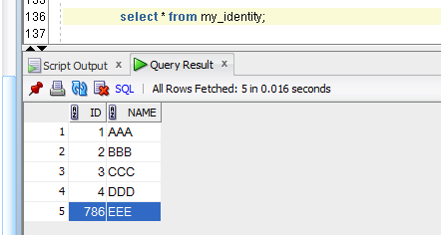

It wont allow to insert NULL values.

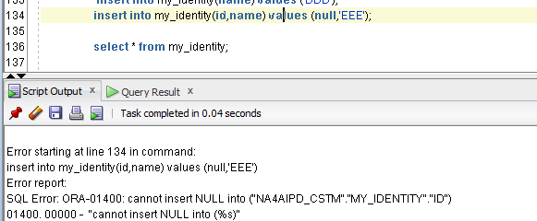

**Both can be overcome by using generated by default on null as identity**

create table my_identity(id number **generated by default on null as identity**,name varchar2(30));

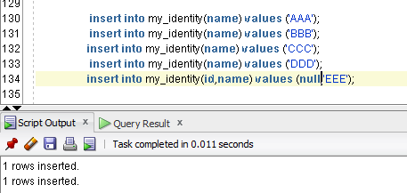

When we try to insert null unique values will be inserted.

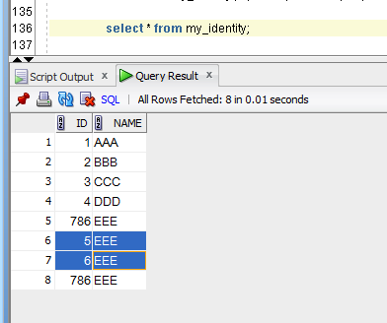

Other than generated always as identity , other two will allow duplicates.

**Same in 11g gives error**

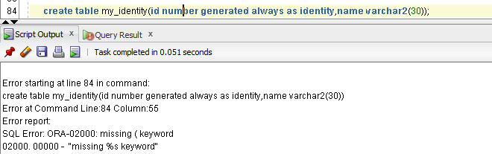

1. **Invisible columns**

The column will be hidded . we can hide sensitive information.

Creating table for demo.

create table my_invisible(id number,name varchar2(30),address varchar2(30) invisible);

if we select that column from select * from tablename, we cant see that column

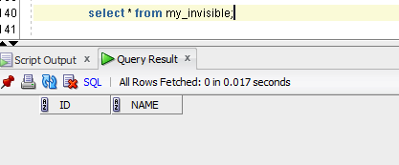

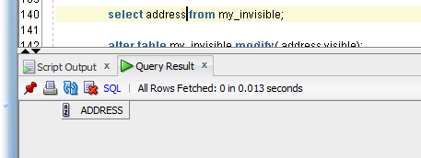

We can alter to make it visible

alter table my_invisible modify( address visible);

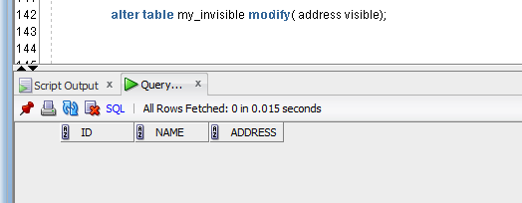

**Same in 11g throws error**

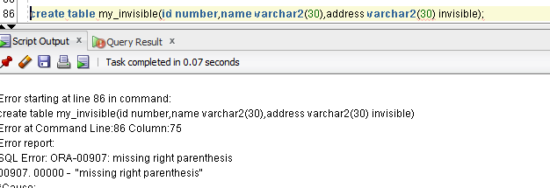

1. **Creating partition on existing table.**

Till 11g below steps are taken to create partition on existing table.

Creating new table with partition

Inserting data from old table to new table

Renaming original table to some archieve table

And renaming new table to original table.

create table non_partition(id number, phone number,salary number);

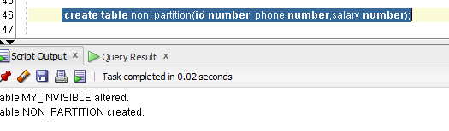

Adding partition

alter table non_partition modify partition by range(id) interval (100)

(partition p1 values less than(100),

partition p2 values less than(200)) online;

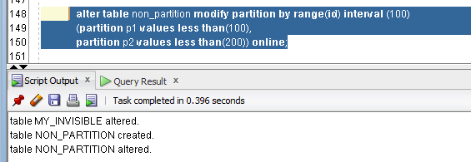

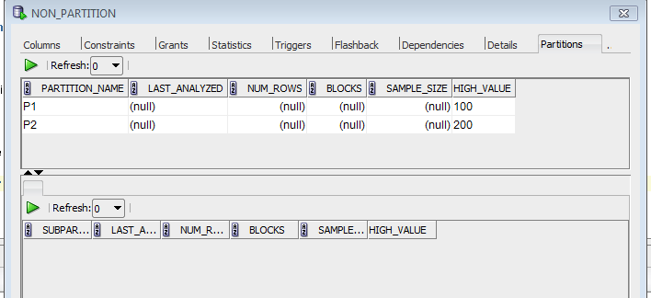

Now lets insert data to table

insert into non_partition values(50,100,400);

insert into non_partition values(190,100,400);

insert into non_partition values(300,100,400);

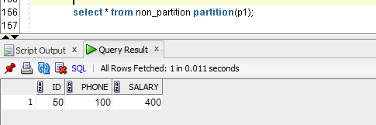

Based on data new partition is created.

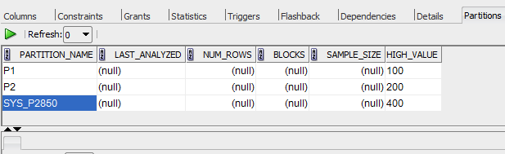

1. **ROW_limiting_clause**

**To fetch first 5 rows**

select alert_internal_id,alert_id,status_internal_id from alerts

order by alert_internal_id

**fetch first 5 rows only;**

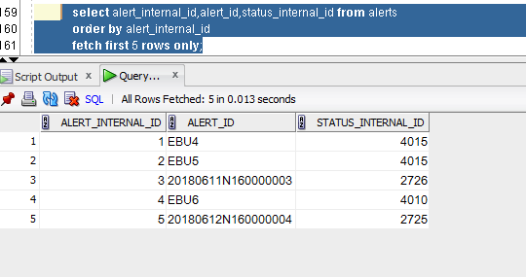

**To fetch 10 percent of data**

select alert_internal_id,alert_id,status_internal_id from alerts

order by alert_internal_id

**fetch first 10 percent rows only;**

**or**

**select alert_internal_id,alert_id,status_internal_id from alerts**

**fetch first 10 percent rows only;**

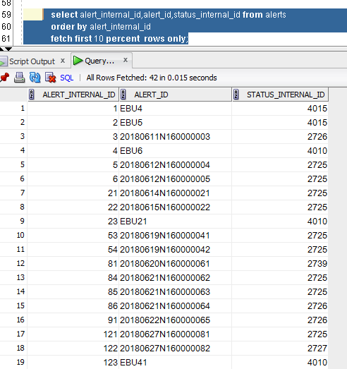

This query skip first 4 rows and disply next 4 rows(to fetch particily position)

select alert_internal_id,alert_id,status_internal_id from alerts

order by alert_internal_id

**offset 4 rows fetch next 4 rows only;**

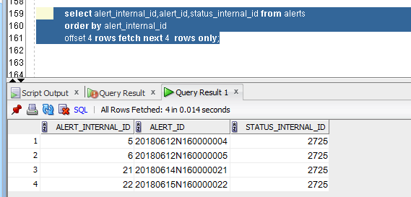

**select alert_internal_id,alert_id,status_internal_id from alerts**

**order by alert_internal_id**

**offset 4 rows fetch next 20 percent rows only;**

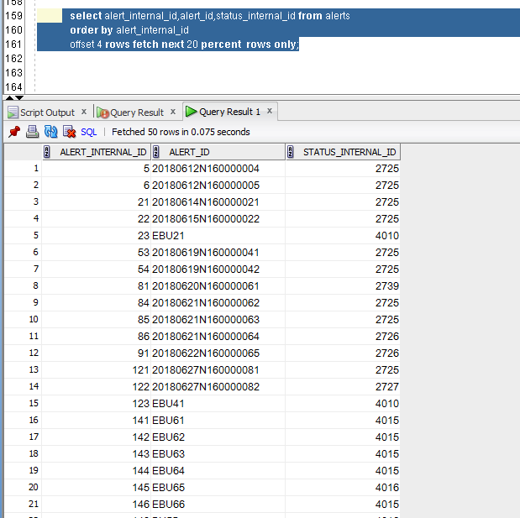

**select alert_internal_id,alert_id,status_internal_id from alerts**

**order by status_internal_id**

**fetch first 5 rows with ties ;**

when using ties order by is compulsory

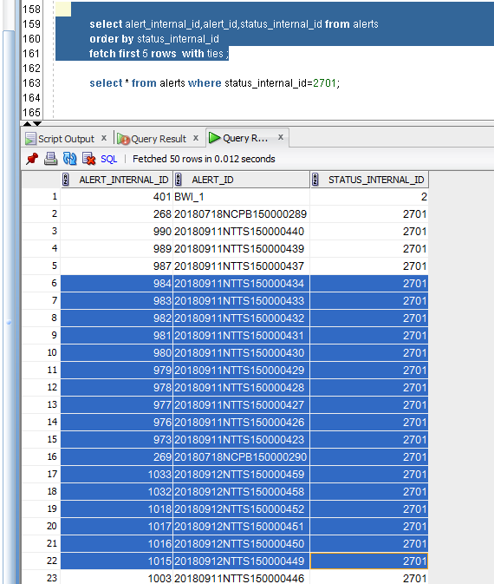

After 5th row is data is there with same value all records will be displayed.

1. **Listagg function in 12c**

select listagg(alert_id,',') within group(order by alert_internal_id ) from alerts

where status_internal_id=2701;

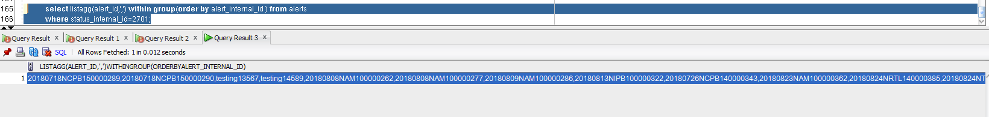

Listagg will throw error if size is more than 4000 bytes

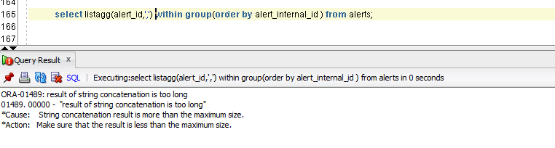

We can over by below option

select listagg(alert_id,',' **on overflow truncate**) within group(order by alert_internal_id ) from alerts;

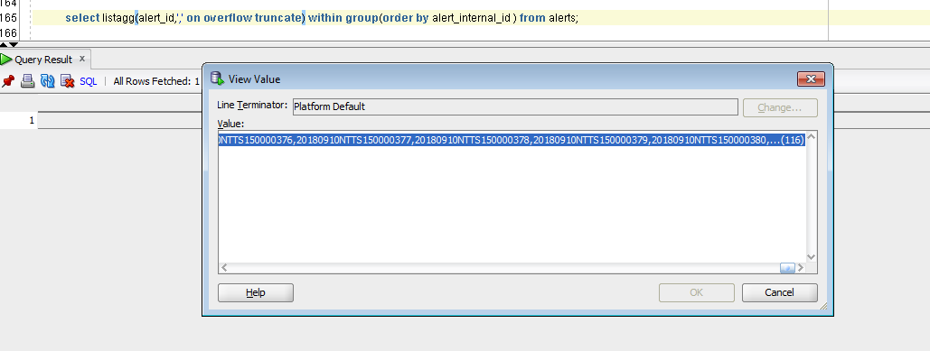

We can give more option like this

select listagg(alert_id,',' on overflow truncate '** SOME MORE EXISTS **') within group(order by alert_internal_id ) from alerts;

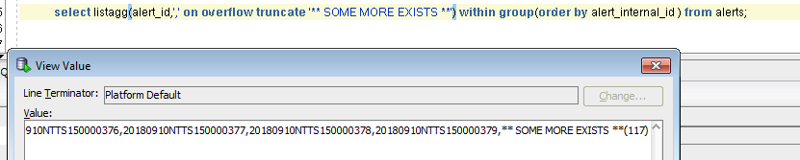

Just to see count with space

select listagg(alert_id,',' on overflow truncate ' ' with count) within group(order by alert_internal_id ) from alerts;

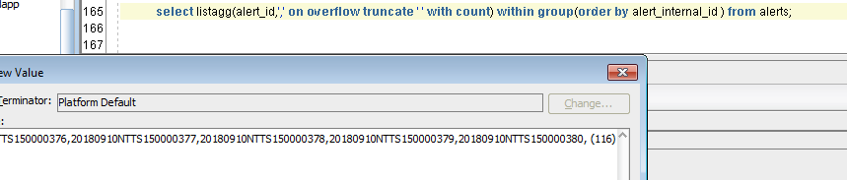

Just to see without count

select listagg(alert_id,',' on overflow truncate ' ' without count) within group(order by alert_internal_id ) from alerts;

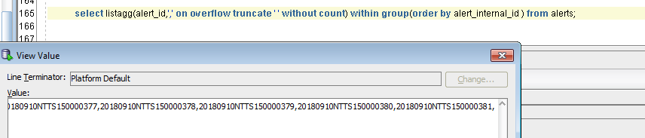

1. **Creating table/sequence names with more than 30 characters**

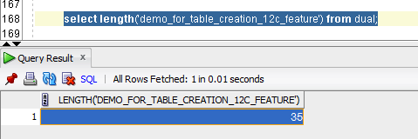

Creating table with that name

create table demo_for_table_creation_12c_feature(id number,name varchar2(30));

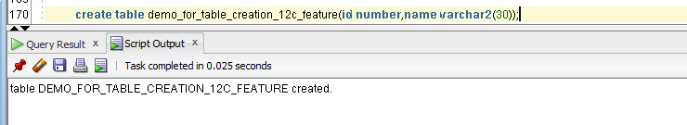

Now creating sequence

create sequence demo_for_table_creation_12c_feature_seq ;

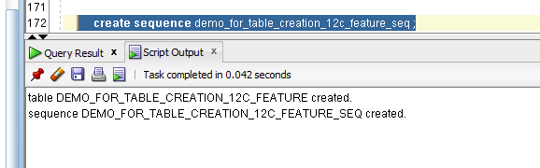

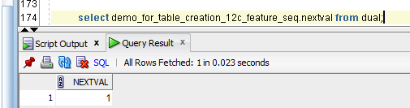

Even view we can create

create view demo_for_table_creation_12c_feature_view as select * from demo_for_table_creation_12c_feature;

view DEMO_FOR_TABLE_CREATION_12C_FEATURE_VIEW created.

1. **With clause with functions**

WITH

FUNCTION findLatestEnrolmentDate IS

.BEGIN

SELECT MAX(enrolment_date)

FROM student;

END;

SELECT first_name, last_name

FROM student

WHERE enrolment_date = findLatestEnrolmentDate;

1. **DDL LOGGING**

Alter system set enable_ddl_logging=TRUE;

Alter session set enable_ddl_logging=TRUE;

We can see log whenever ddl command runs under path oracle_home_directory

Eg

\diag\rdbms\orcl12c\orcl12c\log\ddl

1. **PRAGMA UDF**

**Pragma udf tells the compiler that the plsql unit is a user defined function that is used primarily in SQL statements , which might improves its performance**

**create or replace function fn1(input_num number) return number as**

**pragma udf;**

**begin**

**return input_num*2;**

**end ;**

**we can see it took approx. 2.8 sec**

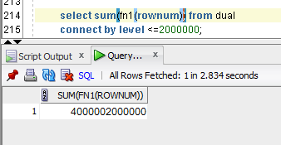

Created function without pragma

create or replace function fn1(input_num number) return number as

begin

return input_num*2;

end ;

/

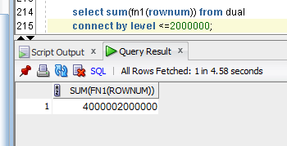

**It took around 4.57 seconds**

**Pragma udf increases the performance**